Predictive Data

Juan Maldonado Franco
Department of Technology, National University
DDS-8500: Principles of Data Science
Dr. Javier E. León
1/13/2026

Predictive Data
This report presents an exploratory data analysis (EDA) of a structured dataset containing demographic, socioeconomic, and behavioral variables, including age, gender, education level, employment status, income, and self-reported happiness. The purpose of this analysis is to summarize and explore the key characteristics of the data using descriptive statistics and visual representations prior to conducting any inferential or predictive modeling.
Exploratory data analysis plays a central role in modern data science by supporting an iterative process of data transformation, visualization, and interpretation that enables analysts to understand distributions, identify patterns, detect anomalies, and assess data quality (Wickham et al., 2010). In this study, the dataset was first cleaned and structurally corrected to address missing values, schema misalignment, and data type inconsistencies. Following this preparation, descriptive statistics and graphical techniques were applied to examine both numerical and categorical variables.
The primary goal of this report is to extract meaningful descriptive insights regarding the distribution of key variables, the variability within the data, and the relationships between selected categorical attributes. These findings provide a foundational understanding of the dataset and inform future analytical steps, including hypothesis testing and predictive analysis.
Data Presentation
The dataset used in this analysis consists of 500 observations, each representing an individual record. The data include both numerical and categorical variables spanning demographic characteristics, educational attainment, employment status, income, and subjective well-being. After the data cleaning and structural correction phase, the dataset contained 16 variables, excluding identifiers used solely for indexing.
Numerical variables include Age, Height, Weight, Income, Score, and Happiness. These variables are measured on either ratio or interval scales and allow computation of measures such as the mean, median, standard deviation, and range (Kaliyadan & Kulkarni, 2019). Categorical variables include Gender, Education, Marital Status, Employment, Rating, Category, Color, Hobby, and Location, which are measured on nominal or ordinal scales.
The sample size of 500 observations is appropriate for descriptive analysis, as it provides sufficient representation across categories while allowing stable estimation of summary statistics. Although missing values are present, they were intentionally preserved during exploratory analysis to accurately reflect the structure and limitations of the original data.
A structured table summarizing variable types and measurement scales is included to support clarity and transparency in the presentation of the dataset.
Descriptive Statistics
Descriptive statistics were computed for all numerical variables to summarize central tendency, variability, and distributional shape. The variables analyzed included Age, Height, Weight, Income, Score, and Happiness.
Age exhibited a narrow distribution with a mean of 28.44 and a median of 28, indicating minimal variability across the sample. Income demonstrated substantially greater dispersion, with a mean of 52,408.98 and a significant standard deviation of 9,271.09, highlighting meaningful differences in economic status among participants. Happiness scores were moderately concentrated, with a mean of 7.64 and relatively low variability.
Across all numerical variables, skewness and kurtosis values suggested approximately symmetric distributions with no extreme deviations. These results indicate that the data are well-suited for further exploratory and inferential analysis.
Descriptive Questions
Based on the initial data exploration and descriptive statistics, the following descriptive research questions were developed to guide the exploratory analysis:
1. What is the distribution of Age within the dataset, and how much variability exists among participants?
2. How is Income distributed across the sample, and does it exhibit greater dispersion compared to other numerical variables?
3. How does educational attainment vary by Gender within the dataset?
4. How is Employment status distributed across demographic groups?
These questions focus on both single-variable characteristics and relationships between categorical variables. Prior research in data analytics suggests that demographic attributes such as education, employment, and income are closely associated with socioeconomic outcomes and well-being. Exploring these relationships descriptively provides essential context before performing inferential or predictive analysis.
Visual Representations
Visual representations were used to complement descriptive statistics and to provide intuitive insight into the structure, distribution, and relationships within the dataset. Graphical methods allow patterns and differences to be identified more easily than numerical summaries alone, particularly when communicating findings to non-technical audiences (Knaflic, 2020). The following figures and tables present visual summaries of both numerical and categorical variables examined in this exploratory analysis.
Numerical Variable Distributions
Histograms and boxplots were created for numerical variables to examine distributional shape, central tendency, variability, and potential outliers.
Age Distribution
The distribution of Age was examined using a histogram to visualize the frequency of observations across age values.
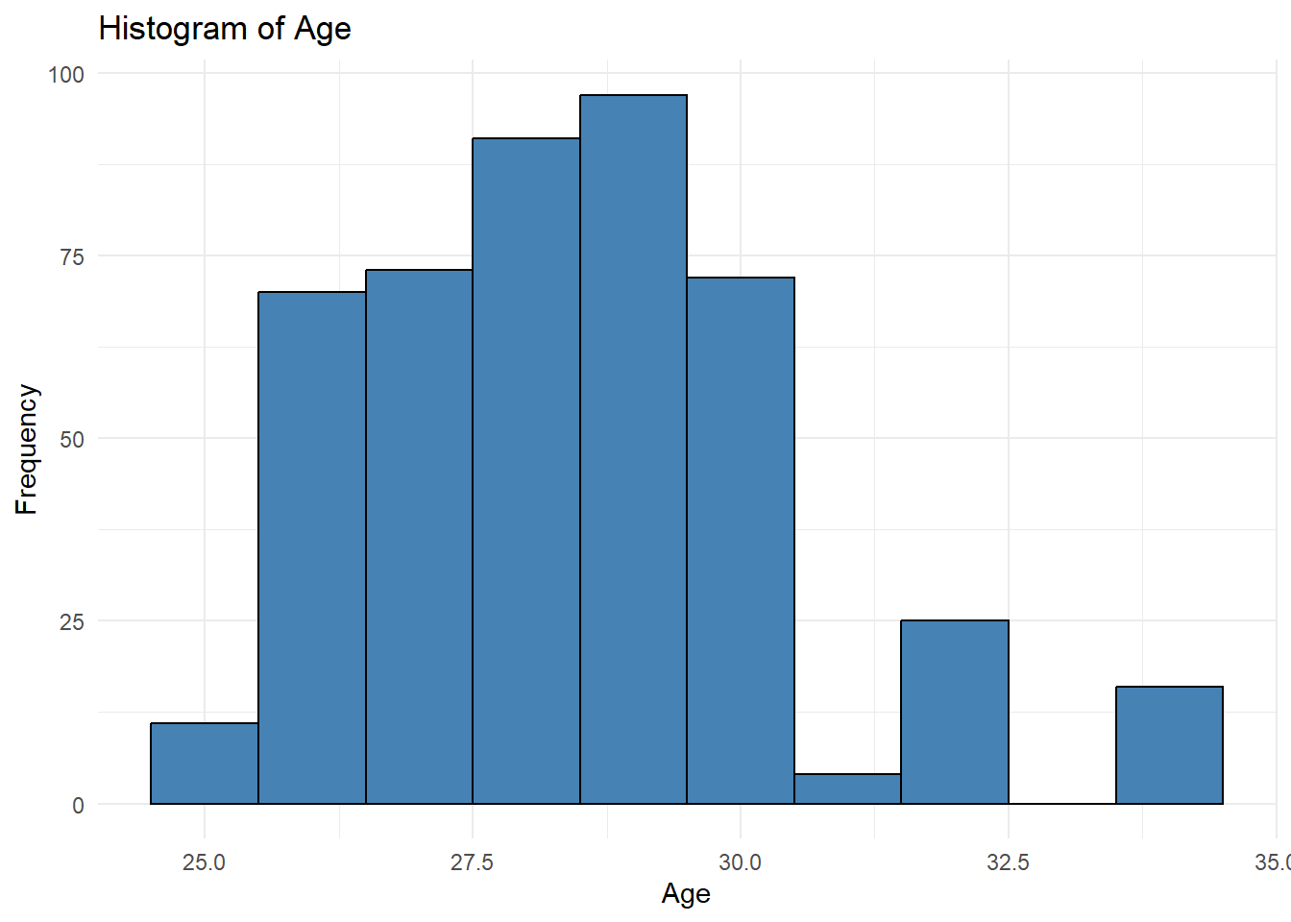
Figure 1
Histogram of Age
The histogram shows that Age values are tightly clustered within a narrow range, with most observations concentrated in the late twenties. This confirms the descriptive statistics, which show that the mean and median were nearly identical. The distribution appears approximately symmetric with a slight right skew, and no extreme age values are evident.
To further assess variability and outliers, a boxplot of Age was generated.
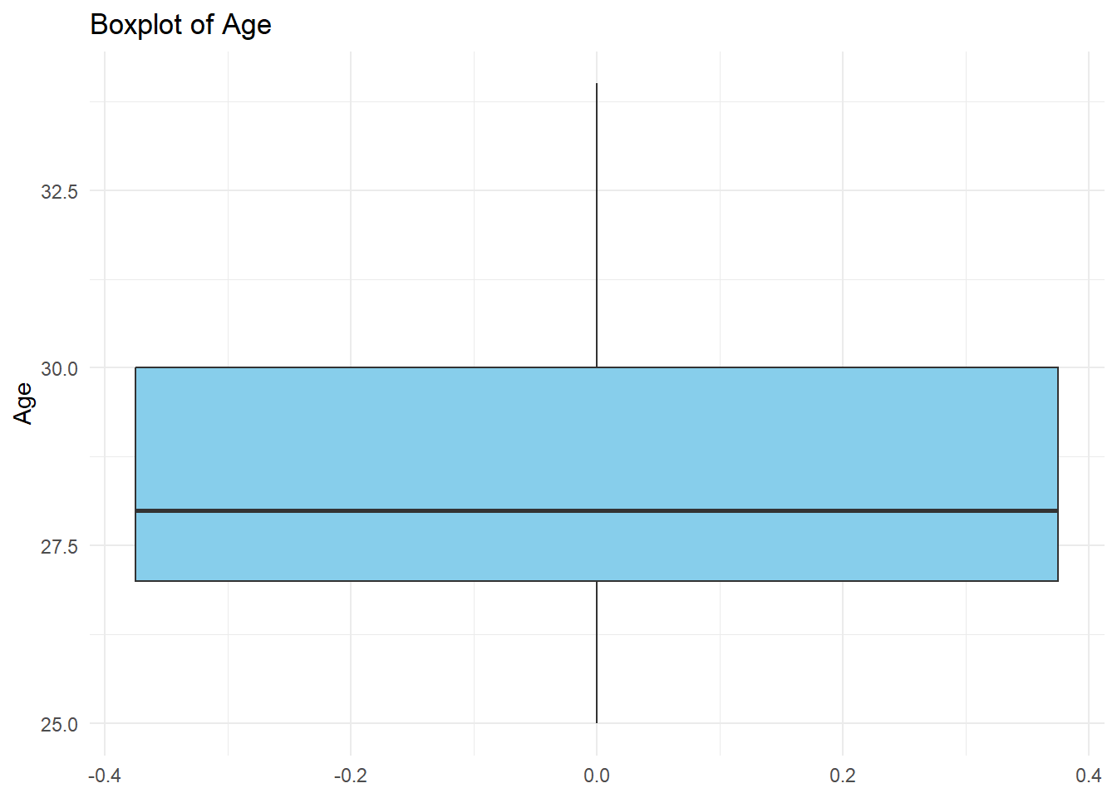
Figure 2
Boxplot of Age
The boxplot shows a small interquartile range (IQR), indicating that the middle 50% of Age values are closely grouped. The median is centrally located within the box, and no significant outliers are present. This reinforces the conclusion that Age exhibits limited variability within the dataset.
Income Distribution
Income was analyzed using a histogram to capture its broader range and higher variability relative to other numerical variables.
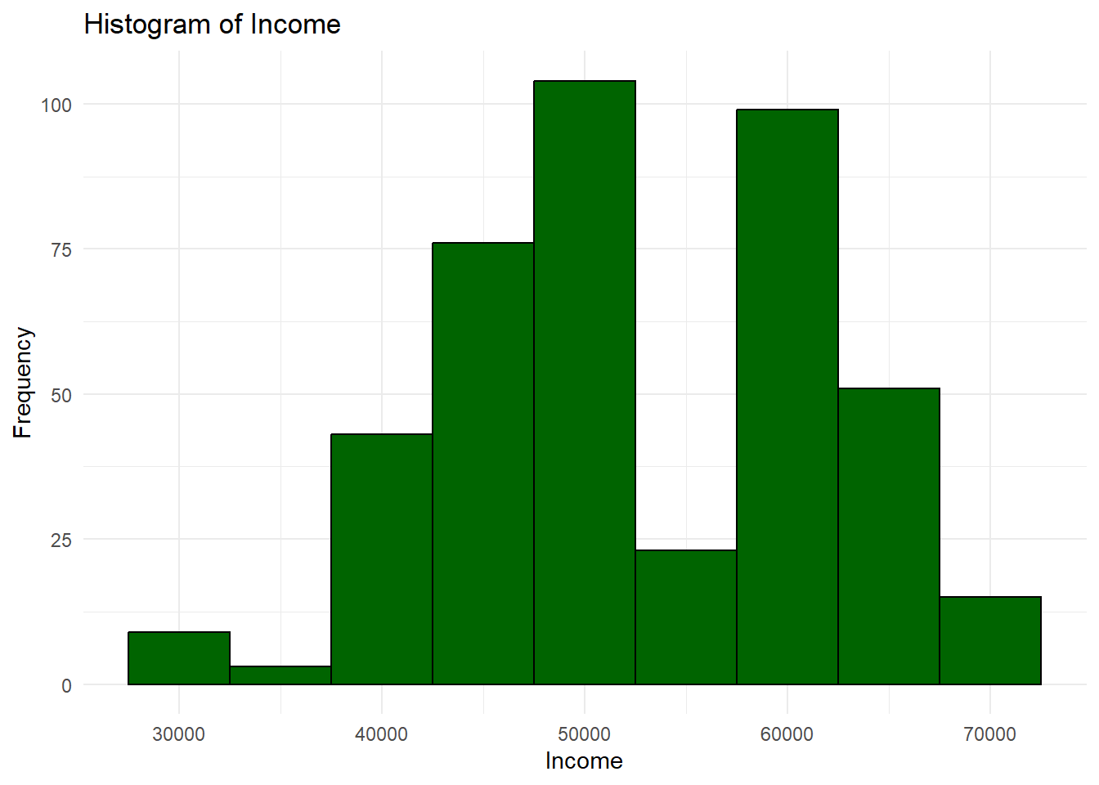
Figure 3
Histogram of Income
The histogram reveals a wider spread of Income values, with observations distributed across multiple income brackets. While the distribution is approximately symmetric, the greater dispersion indicates meaningful differences in economic status among participants. This visual pattern aligns with the high standard deviation observed in the descriptive statistics.
A boxplot was used to evaluate income variability and potential outliers further.
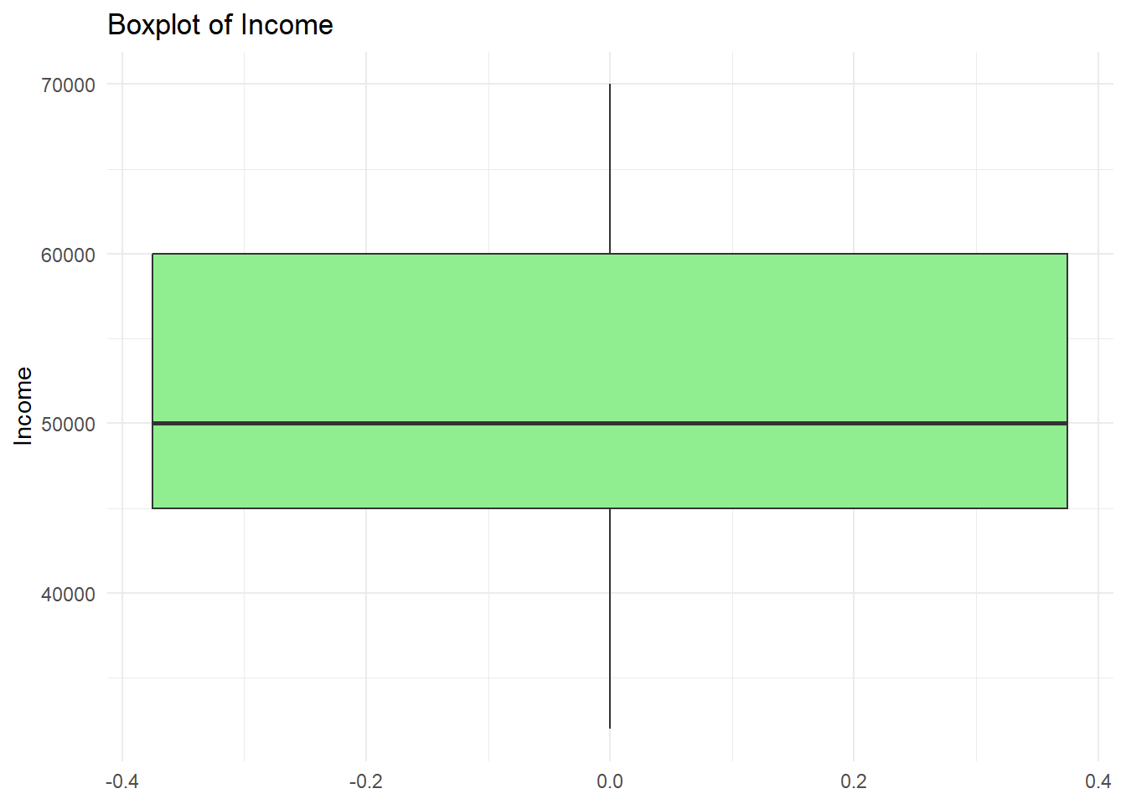
Figure 4
Boxplot of Income
The boxplot confirms that Income has the largest IQR among the numerical variables analyzed. Several values appear at the upper end of the distribution, though no extreme outliers are present. The wide spread suggests that Income may play a more influential role in differentiating outcomes in future analyses.
Happiness Distribution
Happiness scores were visualized to assess overall well-being levels within the dataset.
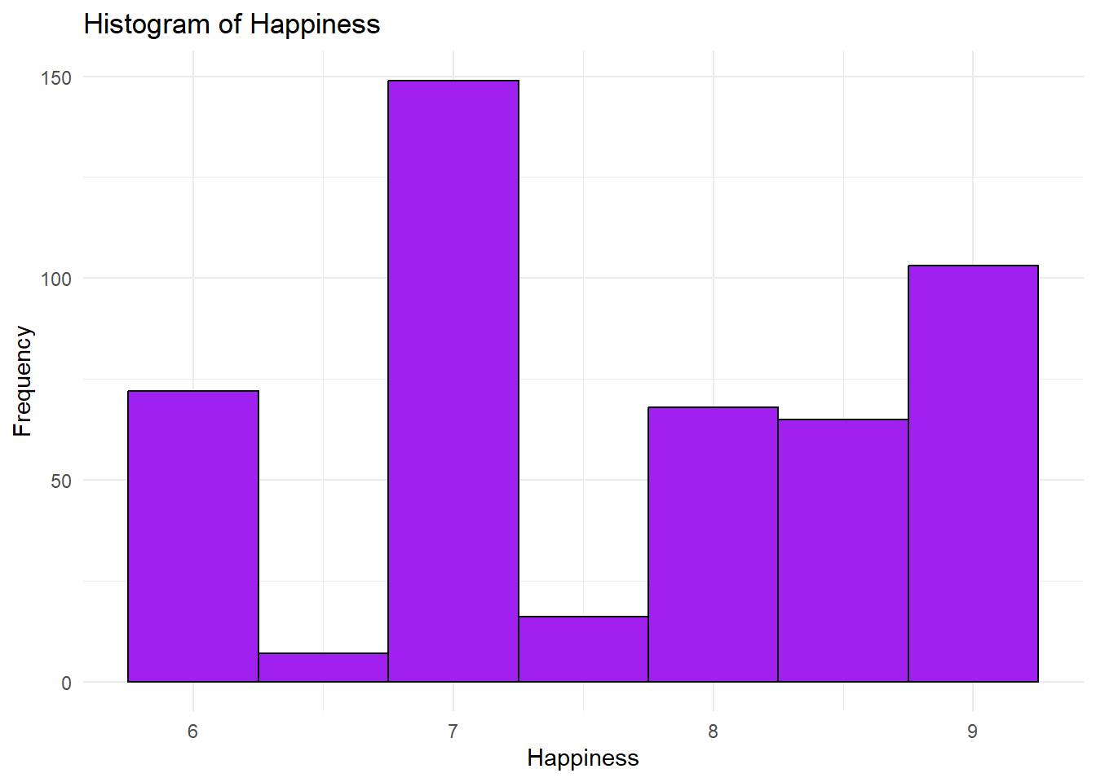
Figure 5
Histogram of Happiness
The histogram shows that Happiness values are moderately concentrated, with most observations falling between scores of 7 and 9. The distribution appears roughly symmetric, indicating that extreme low or high happiness scores are uncommon in the sample.
A boxplot was also generated to evaluate variability and potential outliers.
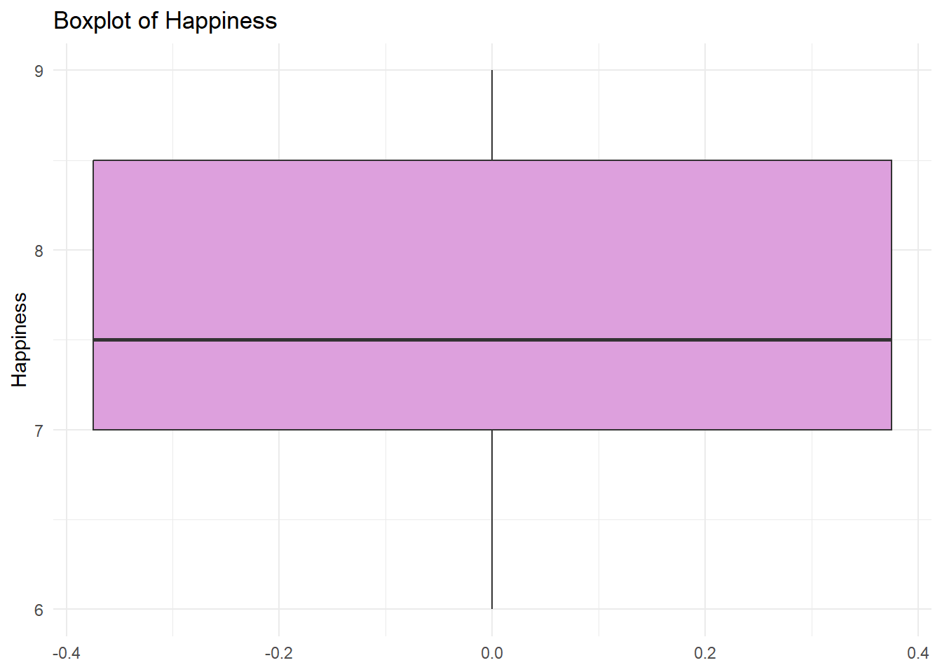
Figure 6
Boxplot of Happiness
The boxplot indicates a relatively small IQR, suggesting limited variability in Happiness scores. The median is positioned near the center of the box, and no substantial outliers are observed. This suggests that self-reported happiness levels are generally consistent across participants.
Categorical Variable Distributions
Bar charts were created for categorical variables to compare the frequency of observations across categories.
Gender Distribution
The distribution of Gender was examined using a bar chart.
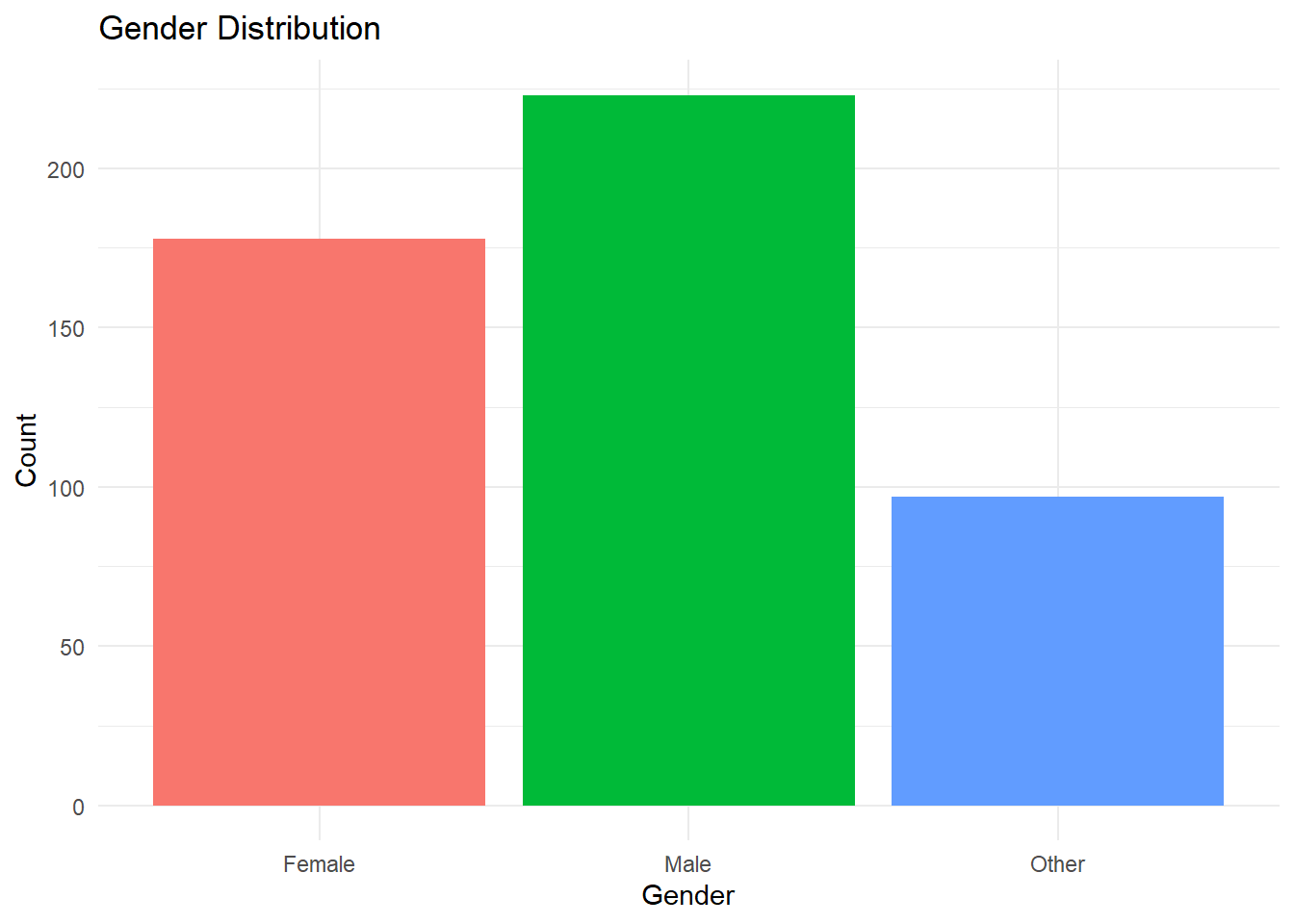
Figure 7
Gender Distribution
The bar chart shows that Male participants represent the largest proportion of the sample, followed by Female participants, with the Other category comprising a smaller share. While all gender categories are represented, the uneven distribution provides important context for interpreting relationships with other variables such as education and income.
Education Level Distribution
Educational attainment was visualized to assess the distribution of educational levels across the sample.
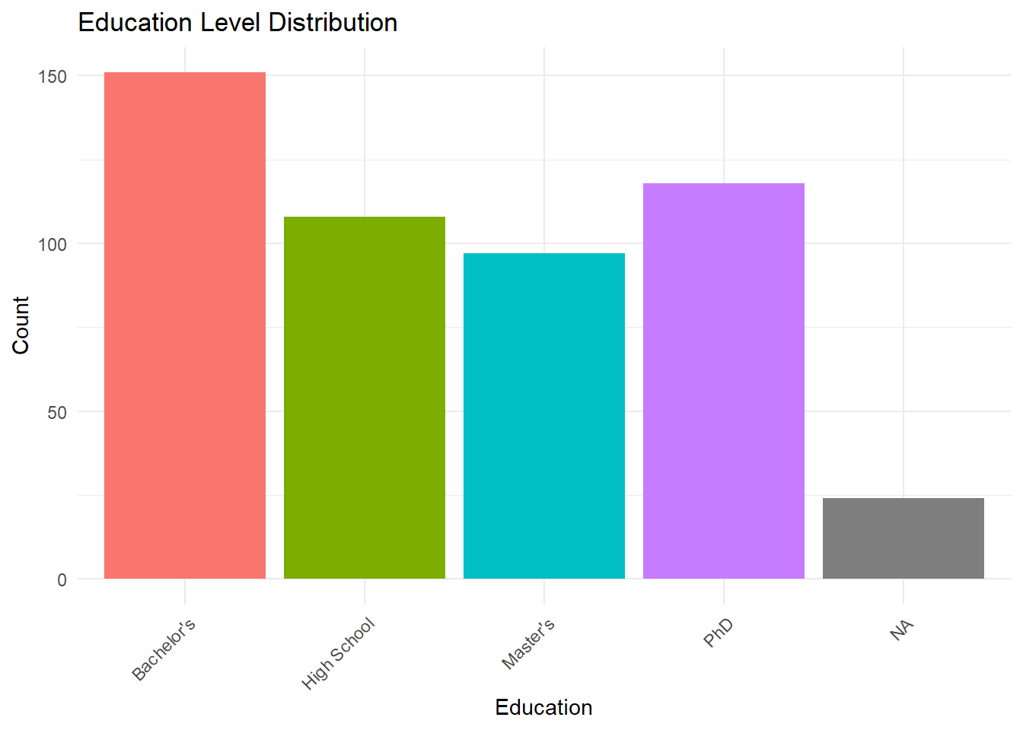
Figure 8
Education Level Distribution
The bar chart indicates that Bachelor’s degrees are the most common level of education in the dataset, followed by High School, Master’s, and PhD levels. This distribution suggests a concentration of participants at the undergraduate level, with fewer individuals represented at advanced degree levels.
Employment Status Distribution
Employment status was examined using a bar chart to summarize labor participation within the dataset.
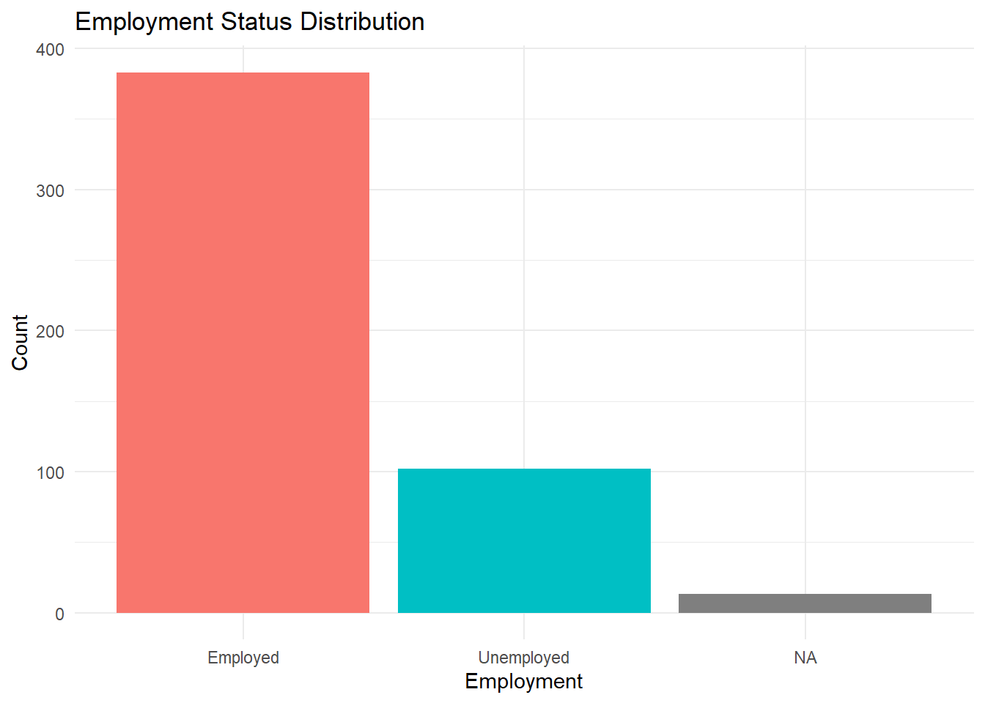
Figure 9
Employment Status Distribution
The bar chart shows that most participants are employed, with a smaller proportion classified as unemployed. This imbalance suggests relatively high labor force participation within the sample and provides important context for interpreting income-related findings.
Relationships Between Categorical Variables
To explore relationships between categorical variables, a contingency table and clustered bar chart were used to examine the association between Gender and Education level.
Table 1
Education Level by Gender
 | Female | Male | Other | Sum
Bachelor's | 138 | 4 | 9 | 151
High School | 10 | 26 | 72 | 108
Master's | 8 | 89 | 0 | 97
Phd | 0 | 103 | 15 | 118
Sum | 156 | 222 | 96 | 474

The contingency table presents the frequency of education levels across gender categories, enabling precise comparisons. The table reveals notable differences in educational attainment between genders, with Female participants primarily concentrated at the Bachelor’s level and Male participants more heavily represented at Master’s and PhD levels.
To complement the tabular summary, a clustered bar chart was generated.
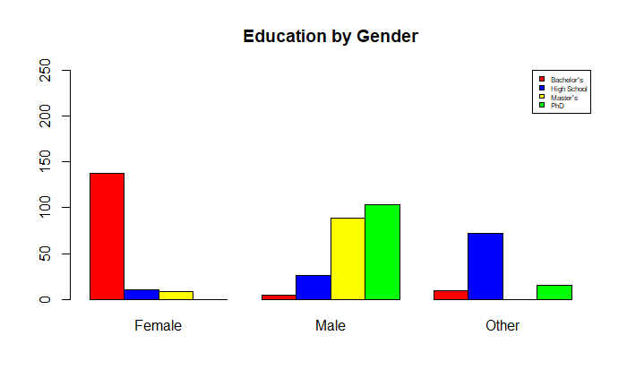
Figure 10
Education Level by Gender (Clustered Bar Chart)
The clustered bar chart visually reinforces the patterns observed in the table. Differences in educational attainment across gender categories are clearly visible, highlighting structural relationships within the dataset. These findings suggest that education may act as an important mediating factor in analyses involving employment and income.
Summary of Visual Findings
Collectively, the visual representations confirm and extend the insights obtained from descriptive statistics. Numerical variables differ substantially in variability, with Income showing the greatest dispersion and Age the least. Categorical analyses reveal meaningful associations, particularly between Gender and Education level. These graphical findings provide a strong descriptive foundation for subsequent inferential or predictive analysis.
Exploration Conclusions
The exploratory data analysis yielded several meaningful insights into the dataset's structure and characteristics. Numerical variables varied substantially in their level of dispersion, with Age showing very limited variability and Income exhibiting the greatest spread. This suggests that Age may be less influential in distinguishing outcomes within this sample, while Income represents a key variable for further analysis.
Visual analysis of categorical variables revealed notable relationships, particularly between Gender and Education level. Female participants were primarily concentrated at the Bachelor’s level, whereas male participants were more heavily represented at the Master’s and PhD levels. These differences highlight structural patterns that may influence related outcomes such as employment status and income.
No extreme anomalies or implausible values were identified after the data cleaning and structural correction process. Missing values were present but preserved intentionally to reflect the true condition of the data during exploratory analysis. Overall, the findings establish a strong descriptive foundation and support the selection of education, employment, and income variables for future inferential or predictive modeling.
Predictive Research Questions
Building on the exploratory data analysis presented in the previous sections, this phase of the analysis shifts from descriptive exploration to predictive modeling. The descriptive findings highlighted meaningful variability in Income, as well as notable demographic patterns related to Age, Gender, and Education. These observations suggest that Income is an appropriate outcome variable for predictive analysis and that demographic and socioeconomic characteristics may provide explanatory value.
Predictive analytics aims to estimate future or unknown outcomes by modeling relationships between variables using statistical techniques such as linear regression. In this context, predictive modeling allows for the evaluation of how individual and combined predictors contribute to variation in Income, while also assessing model adequacy and practical significance.
Based on the exploratory findings and the correlation evidence summarized below, the following predictive research questions were developed.
Predictive Research Question 1
RQ1: To what extent does Age predict Income among individuals in the dataset?
This question examines whether Age alone provides meaningful predictive information about Income. Prior research in labor economics and data analytics suggests that income often increases with age due to accumulated work experience, skill development, and career progression. However, the strength of this relationship varies depending on contextual factors such as education and labor market structure.
From a practical perspective, understanding the predictive value of Age can inform baseline expectations in workforce and socioeconomic analyses. This relationship may be relevant to organizations involved in workforce planning, compensation analysis, or demographic forecasting. The single linear regression model associated with this question provides a clear and interpretable foundation for evaluating predictive strength, statistical significance, and model fit.
Predictive Research Question 2
RQ2: How do Age, Gender, and Education jointly predict Income when considered simultaneously?
While Age may be associated with Income, it is unlikely to fully explain income variation on its own. Education level and Gender are well-documented factors in income research and often interact with age-related trends. This second research question extends the analysis by incorporating both numerical and categorical predictors into a multiple linear regression model.
Evaluating these predictors simultaneously allows for the assessment of their independent contributions while controlling for the influence of the others. This approach provides a more realistic and robust predictive framework than a single-variable model. The results of this analysis are particularly relevant for stakeholders interested in understanding structural income differences, such as policymakers, organizational leaders, and analysts examining equity and labor market outcomes.
Together, these two predictive research questions establish a progression from a simple baseline model to a more comprehensive multivariable model. This structure supports both interpretability and analytical rigor and provides a foundation for evaluating predictive performance, model adequacy, and practical implications using the regression results presented below.
Correlation Analysis
Prior to estimating regression models, a correlation analysis was conducted to evaluate the strength and direction of relationships among the numerical variables included in the dataset. Correlation analysis provides an important preliminary assessment of whether linear predictive modeling is appropriate and helps identify which variables may offer meaningful explanatory value.
A correlation matrix was generated to summarize pairwise correlations among the selected numerical variables, including Age, Income, Happiness, Score, Height, and Weight.
Table 2
Correlation Matrix of Numerical Variables
 | Age | Income | Happiness | Score | Height | Weight
Age | 1 | 0.530108 | 0.454177 | 0.639117 | 0.646801 | 0.64231
Income | 0.530108 | 1 | 0.697366 | 0.873922 | 0.55318 | 0.460587
Happiness | 0.454177 | 0.697366 | 1 | 0.813178 | 0.140197 | 0.031301
Score | 0.639117 | 0.873922 | 0.813178 | 1 | 0.336212 | 0.198927
Height | 0.646801 | 0.55318 | 0.140197 | 0.336212 | 1 | 0.986797
Weight | 0.64231 | 0.460587 | 0.031301 | 0.198927 | 0.986797 | 1
The correlation coefficients indicate that Income exhibits a moderate positive association with Age, supporting the selection of Age as a predictor variable in the initial regression model. Stronger associations are observed between Income and Score, as well as between Income and Happiness, suggesting that income in this dataset is closely related to performance-related and subjective well-being measures. In contrast, Height and Weight display an extremely high correlation, indicating redundancy between these variables and reinforcing their exclusion from regression modeling to avoid multicollinearity.
To provide a more intuitive summary of these relationships, a correlation heatmap was used.
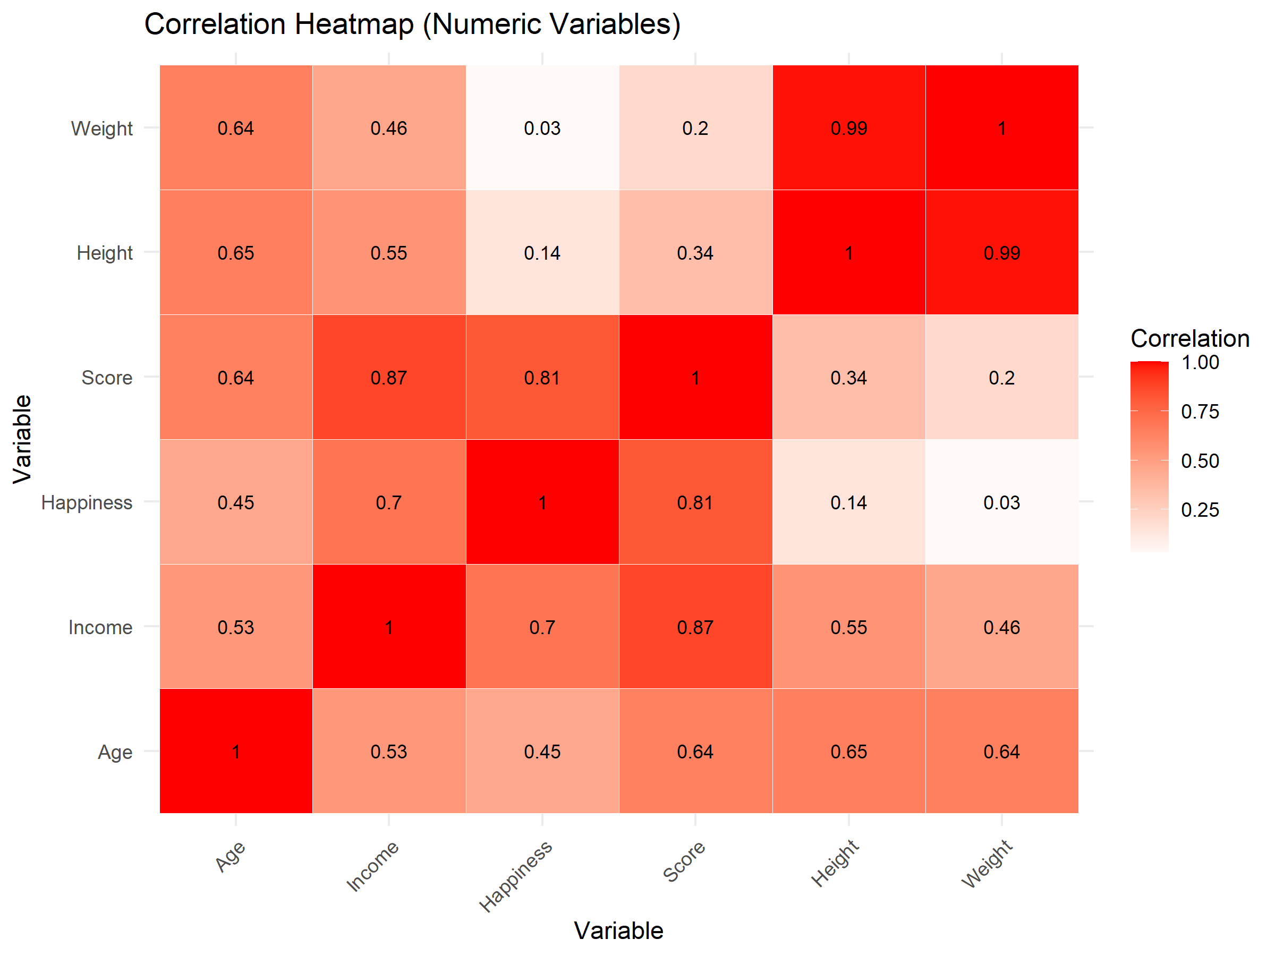
Figure 11
Correlation Heatmap of Numerical Variables
The heatmap visually highlights the relative strength and direction of correlations, making it easier to distinguish strong, moderate, and weak associations. Importantly, the primary predictors used in subsequent regression models (Age, Gender, and Education) do not exhibit extreme correlations with one another, reducing concerns about severe multicollinearity.
It is important to note that correlation analysis identifies association rather than causation. The observed relationships do not imply that changes in one variable directly cause changes in another. Instead, the correlation results serve as an exploratory screening tool that informs model specification and variable selection. This analysis provides evidence of a strong correlation, supporting the use of linear regression as a reasonable predictive approach and motivating the inclusion of additional demographic variables to improve explanatory power.
Overall, the correlation analysis establishes a clear analytical bridge between the exploratory findings and the predictive models that follow.
Linear Regression Models
To address the predictive research questions, linear regression models were estimated to quantify the relationship between Income and selected demographic predictors. Linear regression is an appropriate predictive method when relationships between variables are approximately linear and when model assumptions are reasonably satisfied. The results presented below evaluate both a simple baseline model and a more comprehensive multivariable model.
Model 1: Single Linear Regression (Income ~ Age)
The first model examines whether Age alone provides meaningful predictive information about Income.
Table 3
Single Linear Regression Results for Income ~ Age
Term | Estimate | Std. Error | t value | Pr(>|t|)
(Intercept) | -12949.5 | 5257.291 | -2.46315 | 0.014204
Age | 2273.314 | 184.3659 | 12.33045 | 1.03E-29
The estimated coefficient for Age is positive and statistically significant, indicating that Income tends to increase as Age increases. The associated p-value is well below conventional significance thresholds, providing strong evidence that Age is related to Income in this dataset. This finding aligns with expectations from socioeconomic research, where age is often associated with increased work experience and earning potential.
The coefficient of determination (R²) indicates that Age explains a modest portion of the total variation in Income. While the relationship is statistically significant, the R² value suggests that Age alone does not capture the full complexity of income differences among individuals, highlighting the distinction between statistical significance and predictive strength.
A scatterplot was used to visually examine the relationship between Age and Income.
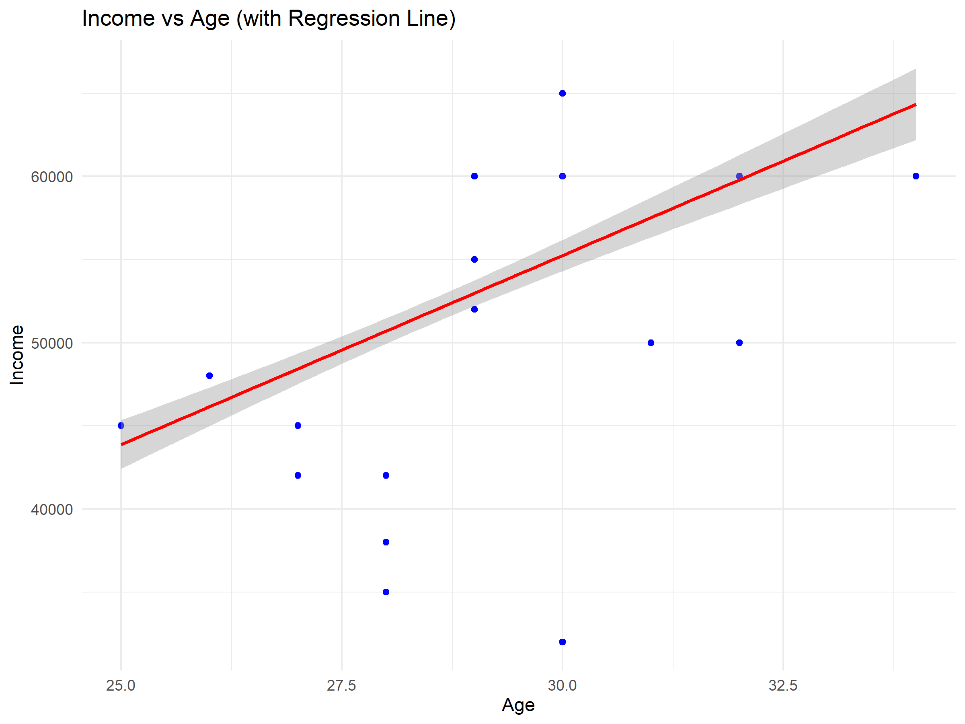
Figure 12
Scatterplot of Income vs. Age with Regression Line
The scatterplot shows a generally upward trend, supporting the assumption of linearity, while also revealing increasing dispersion around the regression line at higher ages. This pattern suggests that income variability grows later in the age range, indicating that while Age contributes to income prediction, it does so with increasing uncertainty. These findings motivate the inclusion of additional predictors in a multivariable model.
Overall, Model 1 serves as a useful baseline, demonstrating that Age is a relevant predictor of Income but is insufficient on its own for strong prediction. The observed relationship between Age and Income is consistent with empirical research showing that earnings tend to increase with age and labor market experience while explaining only a limited portion of overall income variation (Lemieux, 2014).
Model 2: Multiple Linear Regression (Income ~ Age + Gender + Education)
To improve predictive performance and account for additional sources of variation, a multiple linear regression model was estimated using Age, Gender, and Education as predictors.
Table 4
Multiple Linear Regression Results for Income ~ Age + Gender + Education
Term | Estimate | Std. Error | t value | Pr(>|t|)
(Intercept) | 59763.88 | 3898.987 | 15.32805 | 3.37E-41
Age | -483.039 | 145.7803 | -3.31347 | 0.001015
Gender Male | 3093.588 | 758.2523 | 4.079892 | 5.55E-05
Gender Other | -2406.35 | 856.7312 | -2.80876 | 0.005244
Education High School | -9844.5 | 728.3256 | -13.5166 | 5.69E-34
Education Master's | 13021.5 | 874.8264 | 14.88467 | 2.08E-39
Education PhD | 11275.89 | 840.4625 | 13.41629 | 1.41E-33
The multiple regression model exhibits a substantially higher R² and adjusted R² compared to the single-predictor model, indicating that the inclusion of Gender and Education significantly improves the model’s explanatory power. This result demonstrates the value of incorporating both numerical and categorical variables when modeling complex socioeconomic outcomes such as Income.
Interpreting the coefficients relative to their reference categories, Education emerges as a particularly strong predictor of Income. Higher levels of educational attainment are associated with substantially higher predicted Income, while lower levels are associated with lower predicted Income. Gender also shows statistically significant differences in predicted Income across categories, even after controlling for Age and Education. The coefficient for Age changes in magnitude and direction compared to the single-variable model, reflecting the interdependence among predictors and illustrating how controlling for additional variables can alter individual effects.
Regression diagnostics were examined to assess model assumptions.
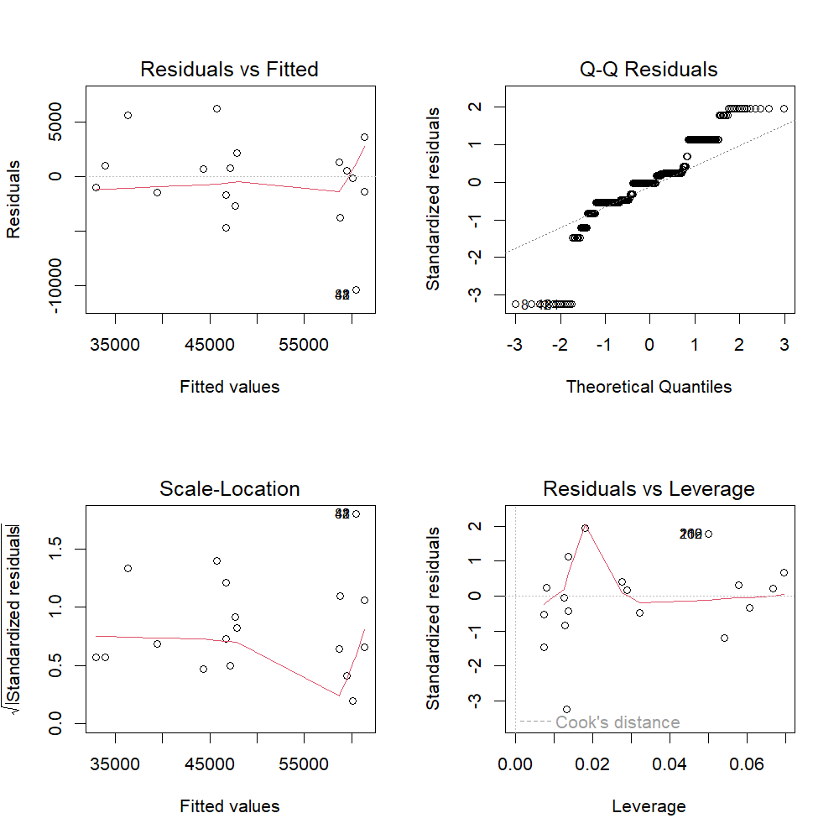
Figure 13
Regression Diagnostics for Multiple Linear Regression Model
The diagnostic plots suggest that linearity and approximate normality of residuals are largely satisfied, although mild deviations are observed at higher fitted income values. These patterns are common in income data and indicate some heteroscedasticity at the upper end of the income distribution, but no extreme violations or highly influential observations were identified that would undermine the model’s suitability for exploratory predictive purposes.
The strong predictive contribution of Education and the persistence of income differences across Gender categories are consistent with extensive empirical research demonstrating that educational attainment and gender remain key determinants of earnings, even after controlling for age and experience (Blau & Kahn, 2017). More recent large-scale evidence further reinforces the presence of gender-related income disparities across diverse labor markets, supporting the inclusion of Gender as a meaningful predictor in income models (Muñoz et al., 2025).
A summary of model sample sizes and missing data was used to evaluate potential limitations.
Table 5
Model Sample Size and Missing Data Summary
Model | Total_Observations | Observations_Used | Observations_Dropped
Single Regression | 498 | 391 | 107
Multiple Regression | 498 | 368 | 130
While some observations were excluded due to missing predictor values, the remaining sample is sufficiently large to support stable estimation and meaningful interpretation of results.
Model Comparison and Interpretation
Comparing the two models highlights the limitations of single-predictor approaches and the advantages of multivariable modeling. While the single regression demonstrates that Age is related to Income, the multiple regression reveals that Education and Gender account for a substantial portion of income variation that Age alone cannot explain.
From a predictive standpoint, the multiple regression model provides a more realistic and informative representation of income dynamics. From an analytical perspective, this progression from a simple to a more complex model illustrates best practices in predictive analysis: begin with an interpretable baseline and then expand the model to improve explanatory and predictive performance while monitoring assumptions and limitations.
Together, these regression analyses address the predictive research questions and demonstrate how linear regression can be used to evaluate both individual and combined predictors of Income in a structured and methodologically sound manner.

References
Blau, F. D., & Kahn, L. M. (2017). The Gender Wage Gap: Extent, Trends, and Explanations. Journal of Economic Literature, 55(3), 789–865. https://doi.org/10.1257/jel.20160995
Databricks. (2020). Big book of data science (2nd ed.). Databricks.
https://www.databricks.com/resources/big-book-of-data-science
Kaliyadan, F., & Kulkarni, V. (2019). Types of variables, descriptive statistics, and sample size. Indian Dermatology Online Journal, 10(1), 82–86.
https://doi.org/10.4103/idoj.IDOJ_468_18
Knaflic, S. N. (2020). *Storytelling with data: A data visualization guide for business professionals* (2nd ed.). Wiley.
Lemieux, T. (2008). The Changing Nature of Wage Inequality. Journal of Population Economics, 21(1), 21–48. https://doi.org/10.1007/s00148-007-0169-0
Muñoz, E., Sansone, D., & Tampellini, J. (2025). Relative Income and Gender Norms: Evidence from Latin America.
Wickham, H., Cook, D., & Hofmann, H. (2010). Graphical inference for exploratory data analysis. IEEE Transactions on Visualization and Computer Graphics, 16(6), 973–979. https://doi.org/10.1109/TVCG.2010.161

